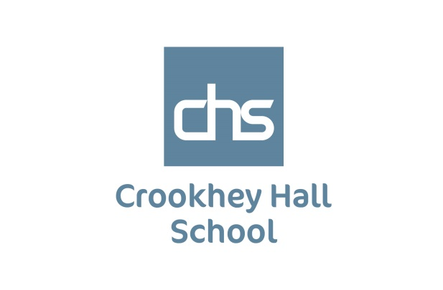

**ACCESSIBILITY PLAN**

**CROOKHEY HALL SCHOOL**

**Updated 1 September 2024**

**Crookhey Hall School Accessibility Plan**

Introduction In 2010 the Equality Act replaced previous anti-discrimination laws with a single Act to make the law simpler and to remove inconsistencies. This makes the law easier for people to understand and comply with. The Act also strengthened protection in some situations. The Act covers nine protected characteristics, which cannot be used as a reason to treat people unfairly. Every person has one or more of the protected characteristics, so the Act protects everyone against unfair treatment. They protected characteristics are:

* Age
* disability
* gender reassignment
* marriage and civil partnership
* pregnancy and maternity
* race
* religion or belief
* sex
* sexual orientation

The Equality Act sets out the different ways in which it is unlawful to treat someone, such as direct and indirect discrimination, harassment, victimisation and failing to make a reasonable adjustment for a disabled person. The Act prohibits unfair treatment in the workplace, when providing goods, facilities and services, when exercising public functions, in the disposal and management of premises, in education and by associations (such as private clubs). It is unlawful for a school or other education provider to treat a pupil with disabilities unfavourably. Such treatment could amount to:

• direct discrimination

• indirect discrimination

• discrimination arising from a disability

**Direct Discrimination**

An education provider must not treat a pupil with disabilities less favourably simply because of their disability. For instance, they can’t refuse admission to applicants because they have a disability

**Indirect Discrimination**

An education provider must not do something for all students which would have a negative effect on any student, unless they have a genuine reason. For example, only providing course application forms in one format, which may not be accessible for disabled people.

**Discrimination arising from a disability**

An education provider must not discriminate against a student because of something that is a consequence of their disability. For example, they can’t stop a pupil with a disability going outside at break time because it takes them too long to get there.

**Harassment**

Education providers must not harass students because of their disability.

**Victimisation**

It is unlawful to victimise a child for anything done in relation to the Act by their parent or sibling/s

**Making adjustments**

Education providers must also make ‘reasonable adjustments’ to ensure that disabled students aren’t discriminated against. Making reasonable adjustments could include:

• changes to practices or procedures

• changes to physical features

• changes to how learners are assessed

• providing extra support and aids (such as specialist teachers or equipment)

**Auxiliary aids**

The Act extends the reasonable adjustment duty to require schools to provide auxiliary aids and services to pupils with disabilities. Following consultation on implementation and approach, the duty came into force on 1 September 2012. The Act makes it unlawful for the body responsible for the school to discriminate against, harass or victimise a pupil or potential pupil:

* in relation to admissions,
* in the way it provides education for pupils,
* in the way it provides pupils access to any benefit, facility or service, or
* by excluding a pupil or subjecting them to any other detriment.

**Accessibility for Parents/carers and Visitors**

Crookhey Hall School is a grade two listed building and due to the constraint’s places upon us by its listing, only the ground floor is accessible for disabled/ wheelchair users. There is ramp access to the building. There is a meeting room on the ground floor and accessible toilets.

Availability of written material in alternative/adapted formats

For all meetings, the School will provide, if required, written information available in alternative formats and languages on request Parents/Carers and visitors can request this from reception or through [reception@crookheyhallschool.co.uk](mailto:reception@crookheyhallschool.co.uk) prior to a meeting, within a reasonable time period.

**Appendices**

**Appendix 1 – Accessibility plan**

This plan aims to ensure that:

* All pupils can participate in the curriculum

• The physical environment of the school enables all pupils and other stakeholders to take better advantage of education, benefits, facilities and services provided • Accessible information is available to all pupils and other stakeholders.

It is a requirement that the school’s accessibility plan is resourced, implemented and reviewed and revised as necessary.

Action points identified below.

|  |  |  |  |  |
| --- | --- | --- | --- | --- |
| **Curriculum target** | **Strategies** | **Timescale** | **Responsible** | **Success criteria** |
| Ensure all class based staff have access to training on disability issues | Complete audit to identify staff training needs and inform the CPD process | Annually | SLT | Increased confidence of staff in strategies of differ |
| Ensure all staff are aware of each pupils needs | Set up an information sharing system for all staff including learning profiles and traffic lights. | Ongoing | SLT | All staff aware of individual pupils access needs and specific medical needs |
| Ensure all staff are able to use the SEN software and resources | List available resources so that staff are aware | Annually | SLT | Resources are used effectively in lessons across the school |

**We are part of the Outcomes First Group Family, by**

**working together we will build incredible futures**

**by empowering vulnerable children, young people**

**and adults in the UK to be happy and make their**

**way in the world.**

